**Learn and Code – Batch 8  
Project - Task Distribution System**

**Team -**Sachin Vaze  
Nivedita Shanker  
Amruta Habib  
Nitin Jangid  
Khushi Jain  
  
**Project Mentor** – Harshith Gowda  
  
**Block Diagram -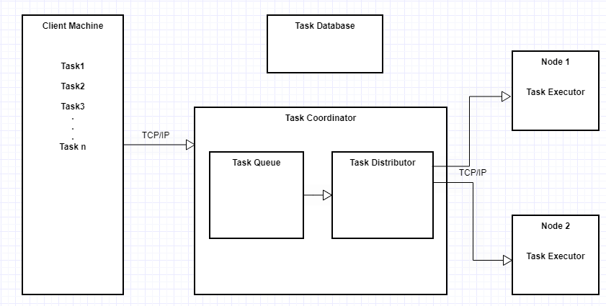 Flow Diagram -  
  
1) Queue Request from Client to Server**

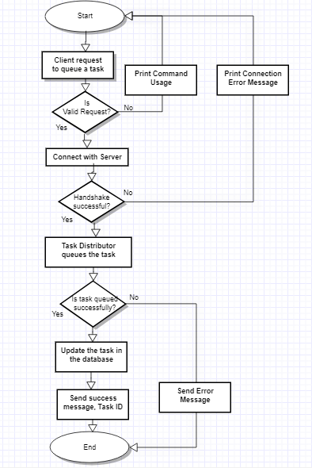

**2) Status Request from Client to Server**

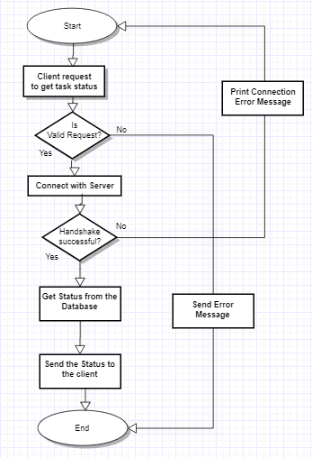

**3) Result Request from Client to Server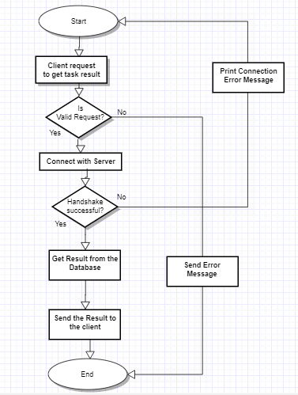 4) Server to Node Request**

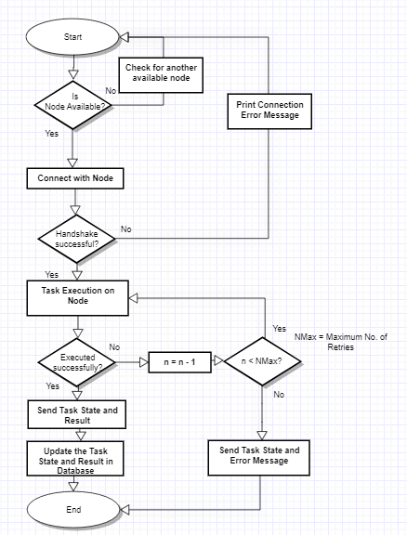 **Class Diagram –**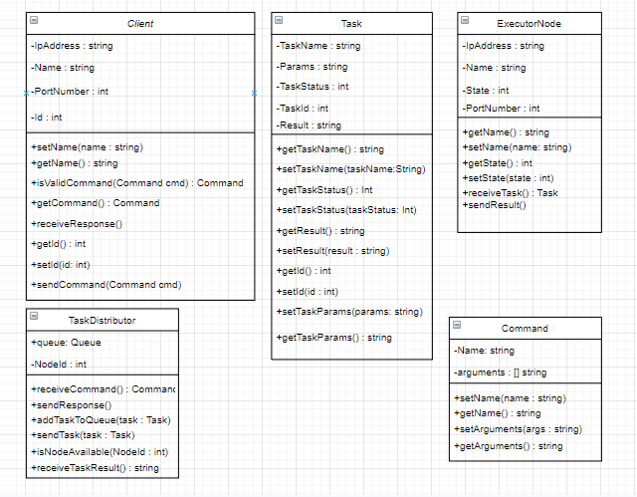

**Sequence Diagram -**